Classwork Blog for Jan. 16
541-790-Extension#

Kimberly Block Extension: 4361 block_k@4j.lane.edu
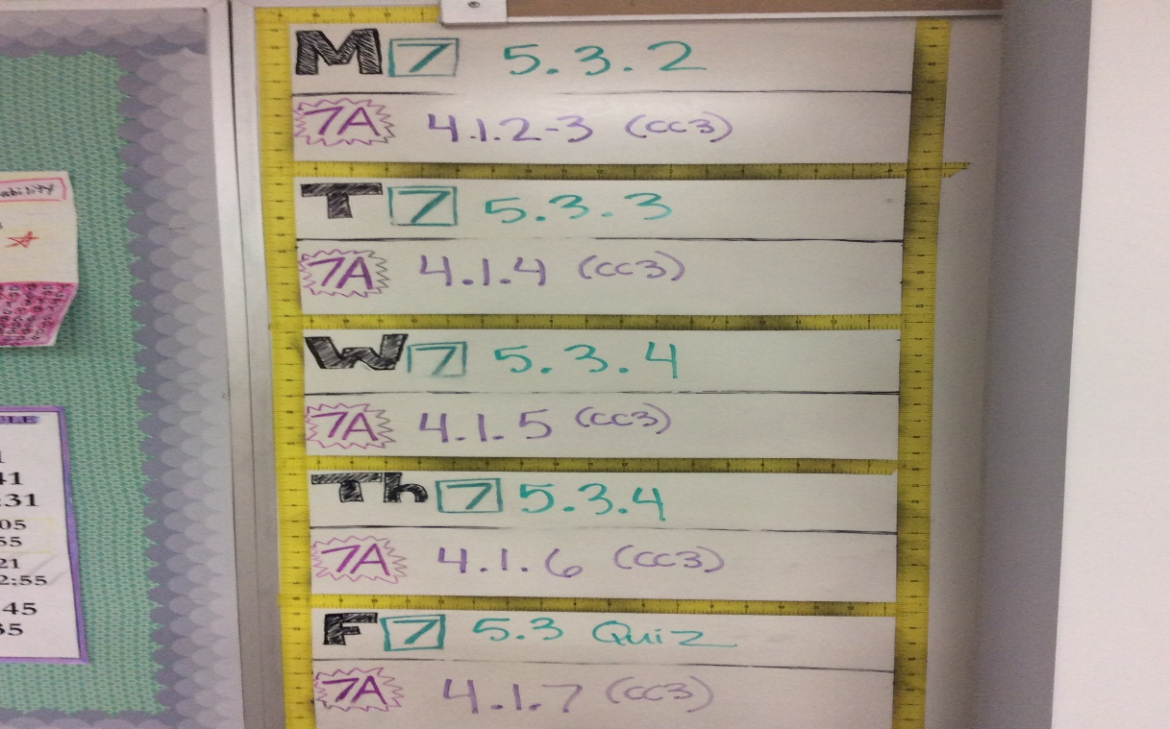
CC2 (7th grade) Homework Help
CC3 (8th grade/7A) Homework Help

Amy Brooks Extension: 4349 brooks_am@4j.lane.edu
LC:

Katie Bushnell Extension: 4344 liane_k@4j.lane.edu
LA 8

Amanda Colburn Extension: 4360 coburn_a@4j.lane.edu
ASL
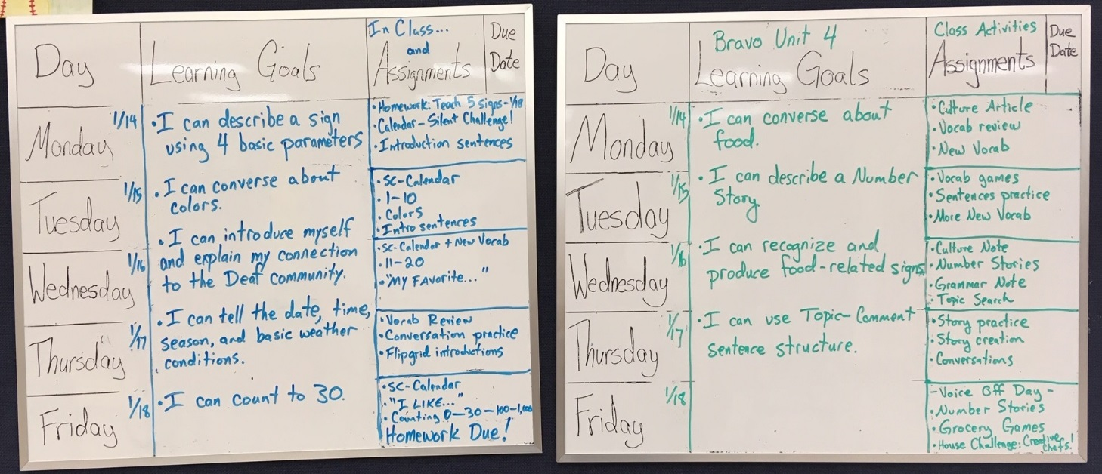

Geoff Davis Extension: 4345 davis_g@4j.lane.edu
Social Studies 8:

Jason Erickson Extension:4366 erickson_j@4j.lane.edu
Social Studies:

AVID 7:
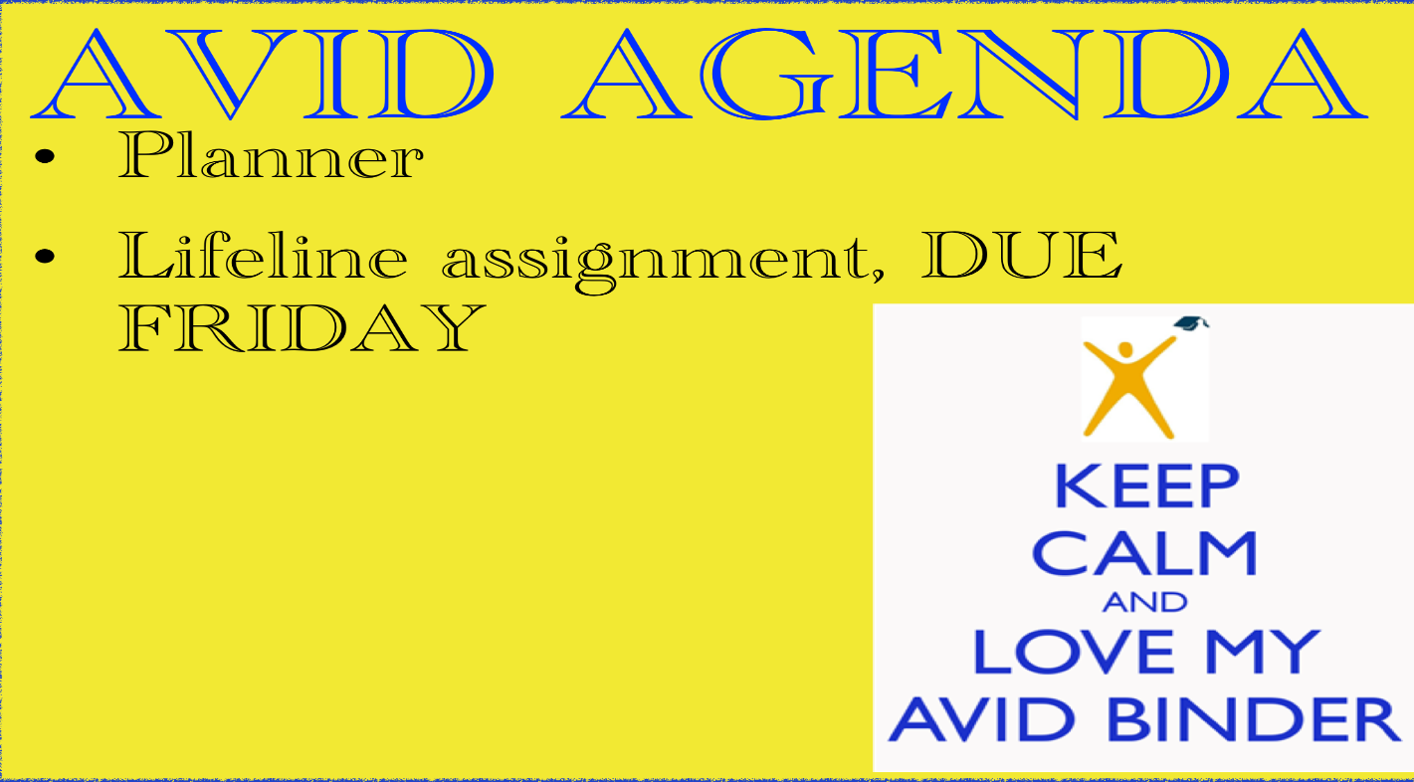

Anne Glassow Extension: 4367 glassow_a@4j.lane.edu
LA 6:
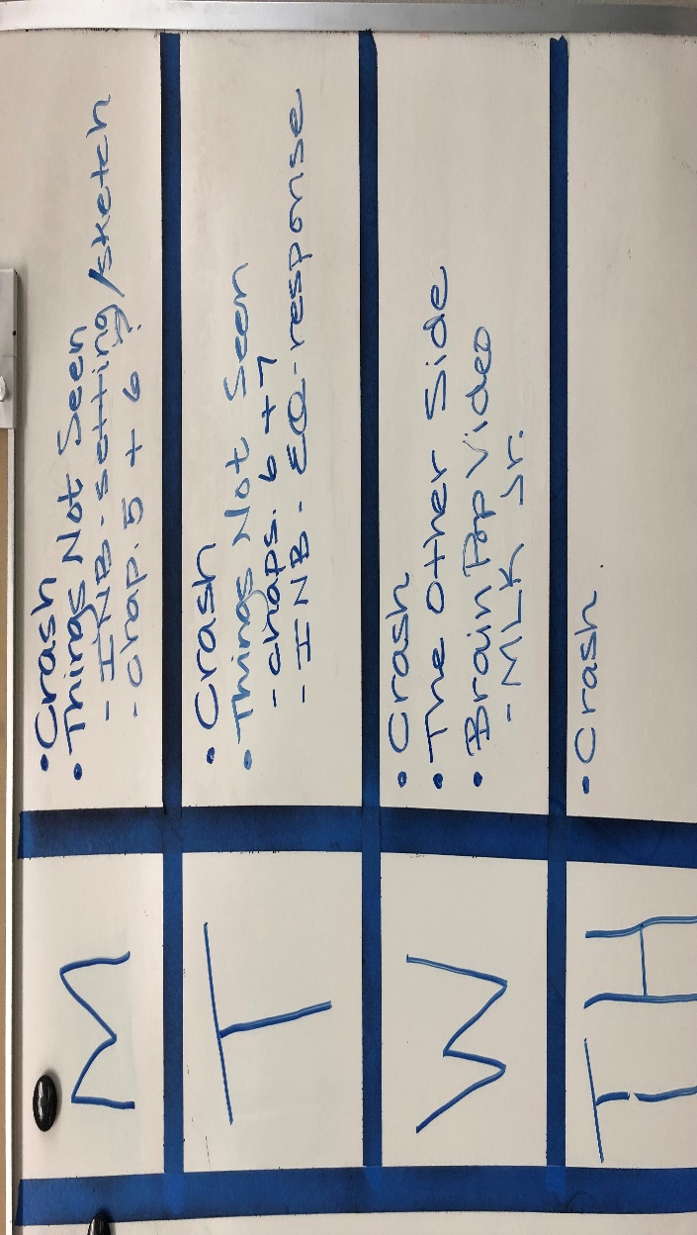

Matt Goodban Extension:4341 goodban_m@4j.lane.edu
CLC

Christina Hinton Extension: 4368 hinton_c@4j.lane.edu
Math 6 & AVID 8:
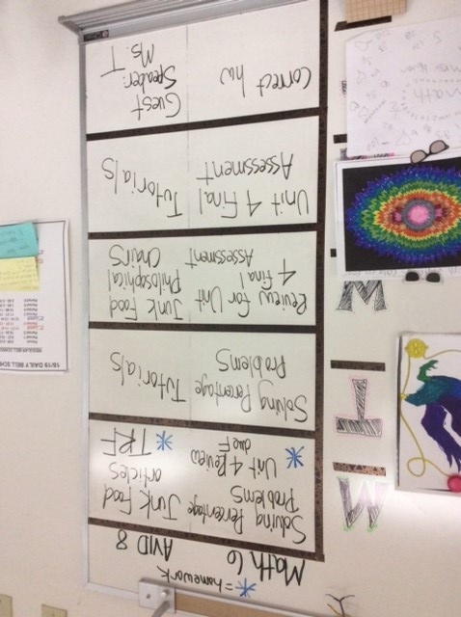
Click here for homework help (English).
Click here for homework help (Spanish).

Kellen Hobie Extension: 4322 hobie_k@4j.lane.edu
Tues-Thursday: Pickle Ball
Friday: Circuit Training

Jessica Johnson Extension:4352 johnson_jes@4j.lane.edu
Science 8:
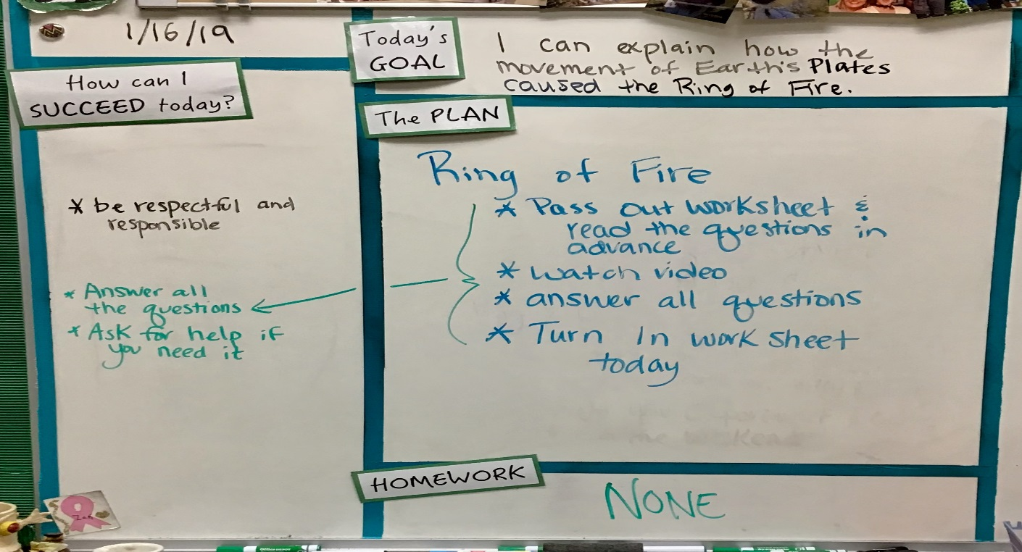

Heath Kliever Extension: 4344 kliever_h@4j.lane.edu
Read180:
Lexile testing, paragraph writing practice using drought essays.
8th LA:
EasyCBM testing (up to two days), To Kill A Mockingbird chapters 1-6, possibly up to chapter 8 if time allows. Students will be allocated time for in-class reading but time at home may be needed to keep on pace. Anticipate two chapters being explored each day. All 8th grade students will have a copy of the book for class and home.
Link to an audio version via YouTube read in a southern accent and approved by Harper Lee. https://www.youtube.com/watch?v=qL83rOXbMfI

Time stamps for chapters: Ch 2: 0:36:12 ch 3: 0:55:39 ch 4: 1:21:34 ch 5: 1:45:00 ch 6: 2:08:05 ch 7: 2:29:46 ch 8: 2:45:18 ch 9: 3:13:38 ch 10: 3:53:00 ch 11: 4:18:55 ch 12: 4:56:09 ch 13: 5:26:43 ch 14: 5:47:58 ch 15: 6:13: 25 ch 16: 6:43:49 ch 17: 7:12:06 ch 18: 7:46:59 ch 19: 8:18:18 ch 20: 8:45:53 ch 21: 9:05:49 ch 22: 9:21:29 ch23: 9:35: 30 ch 24: 10:05:39 ch 25: 10:34:36 ch 26: 10: 44: 59﻿

Lizette Rogers Extension: 4364 rogers_l@4j.lane.edu
Spanish Explore
January Focus: Greetings, numbers, days of the week, and months will be the primary focus this month. There are two tests this month:
Thursday, January 31: Summative Unit Test
Spanish 1
January Focus: We will be finishing Unidad 1. Students will have a summative assessment next week that will involve a written portion and an oral presentation to the class. The assessment will take approximately four days to complete.
Week of January 14: Unit Test & Presentations
Spanish 2
January Focus: Finishing Unidad 3 and our focus on various home structures and family. Students will have a summative assessment next week that will involve a written portion and an oral presentation to the class. The assessment will take approximately four days to complete.
Week of January 28: Unit Test & Presentations
Digital Media
January Focus: Formatting documents, continuation of keyboarding skill development, and positive social media skills.

Alison Machado Extension: 4353 machado_a@4j.lane.edu
6th Grade Science:

Mike Stead Extension: 4363 stubbert_t@4j.lane.edu
Woods/Projects:
Wednesday 1/16
FOCUS - Weekly Independent Guided Work
Per 1 - Working on Tot-stools, measuring, cutting, drilling and shaping parts
Per 3 - Working on cars for donation, measuring, cutting, drilling and shaping parts
Per 4 - Working on individual projects, measuring, cutting, drilling and shaping parts
Per 5 - Working on individual projects, measuring, cutting, drilling and shaping parts
Per 6 - Working on individual projects, measuring, cutting, drilling and shaping parts
Thursday 1/17
FOCUS - Weekly Independent Guided Work
Per 1 - Working on Tot-stools, measuring, cutting, drilling and shaping parts
Per 3 - Working on cars for donation, measuring, cutting, drilling and shaping parts
Per 4 - Working on individual projects, measuring, cutting, drilling and shaping parts
Per 5 - Working on individual projects, measuring, cutting, drilling and shaping parts
Per 6 - Working on individual projects, measuring, cutting, drilling and shaping parts
Friday 1/18
Per 1 - Working on Tot-stools, measuring, cutting, drilling and shaping parts
Per 3 - Working on cars for donation, measuring, cutting, drilling and shaping parts
Per 4 - Working on individual projects, measuring, cutting, drilling and shaping parts
Per 5 - Working on individual projects, measuring, cutting, drilling and shaping parts
Per 6 - Working on individual projects, measuring, cutting, drilling and shaping parts

Tyler Stubbert Extension: 4363 stubbert_t@4j.lane.edu
Social Studies 7:

Ken Walker Extension: 4365 walker_ke@4j.lane.edu
LA 7:

Tim Wilcox Extension: 4336 wilcox_t@4j.lane.edu
Band, Choir, Theater:

Roxanne Winston Extension:4362 winston_r4j.lane.edu
Math 6 & Support:
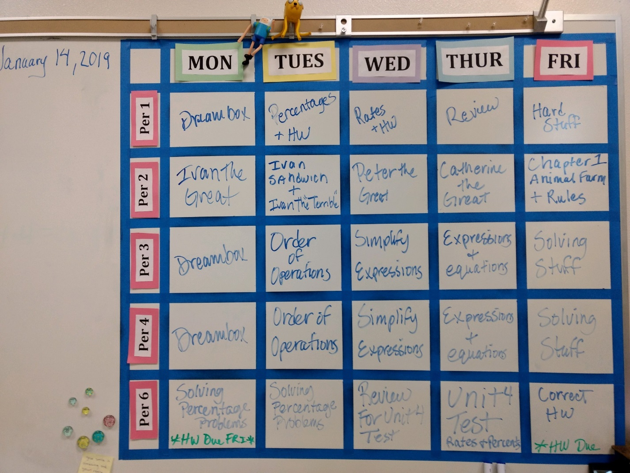

Jan Youngman Extension: 4346 youngman_j@4j.lane.edu
Math 8:
